SIMATS ENGINEERING
ASSESSMENT TOOL 1:
Experiments

COURSE NAME: | Cloud Computing and Big Data Analytics | COURSE CODE: | CSA1519

COURSE OUTCOME COVERED
CO3: Implement cloud-based solutions using cloud storage, web APIs, and platform services for real-world applications. (BL3)

Dave's Taxonomy: Precision (Level 3)  Question Count: 4 | Total Marks: 40

Code of Conduct
I S. MAGALAKSHMI (192524144) (Name / Reg No) certify that this submission is my original work and that I have adhered to the guidelines specified for this assessment.
I understand that any violation of academic integrity rules will result in disciplinary action.

Signature of the student: 

Experiments Rubric
Criteria | Weightage | Level 4 - Exemplary | Level 3 - Proficient | Level 2 - Developing | Level 1 - Beginning
Experimental Design | 25% | Design is systematic and technically strong | Mostly correct design | Basic design with gaps | Poorly designed activity
Use of Tools / Platforms | 20% | Appropriate and effective use of cloud tools | Good tool usage with minor issues | Limited tool usage | Incorrect or missing tool usage
Application of Concepts | 20% | Concepts are applied accurately to practical tasks | Mostly accurate application | Partial application | Weak application
Analysis and Output | 20% | Strong analysis and meaningful outcome interpretation | Good analysis with minor gaps | Basic analysis | Little or no analysis
Documentation | 15% | Clear, structured, and complete documentation | Mostly complete documentation | Partially complete | Poor documentation

Total Marks Awarded

Set 2 - Assessment Tasks

Experiments

Experiment 1: Create a simple cloud software application for Hospital information system for SIMATS Hospital using any Cloud Service Provider to demonstrate SaaS with fields of patient name, age, address, phone, email, Attender name, attender phone, doctor name, diseases, etc.

Experiment 2: Create a simple cloud software application for online super market using any Cloud Service Provider to demonstrate SaaS with the template of customer name, address, phone, email, items, quantity etc. with the item classification form.

Experiment 3: Demonstrate virtualization by Installing Type-2 Hypervisor in your device, create and configure VM image with a Host Operating system (Either Windows/Linux). Create a Virtual Machine with 3 CPU, 10GB RAM and 10GB storage disk using a Type 2 Virtualization Software.

Experiment 4: Demonstrate virtualization by Installing Type-2 Hypervisor in your device, create and configure VM image with a Host Operating system (Either Windows/Linux). Create a Snapshot of a VM and Test it by loading the Previous Version/Cloned VM.

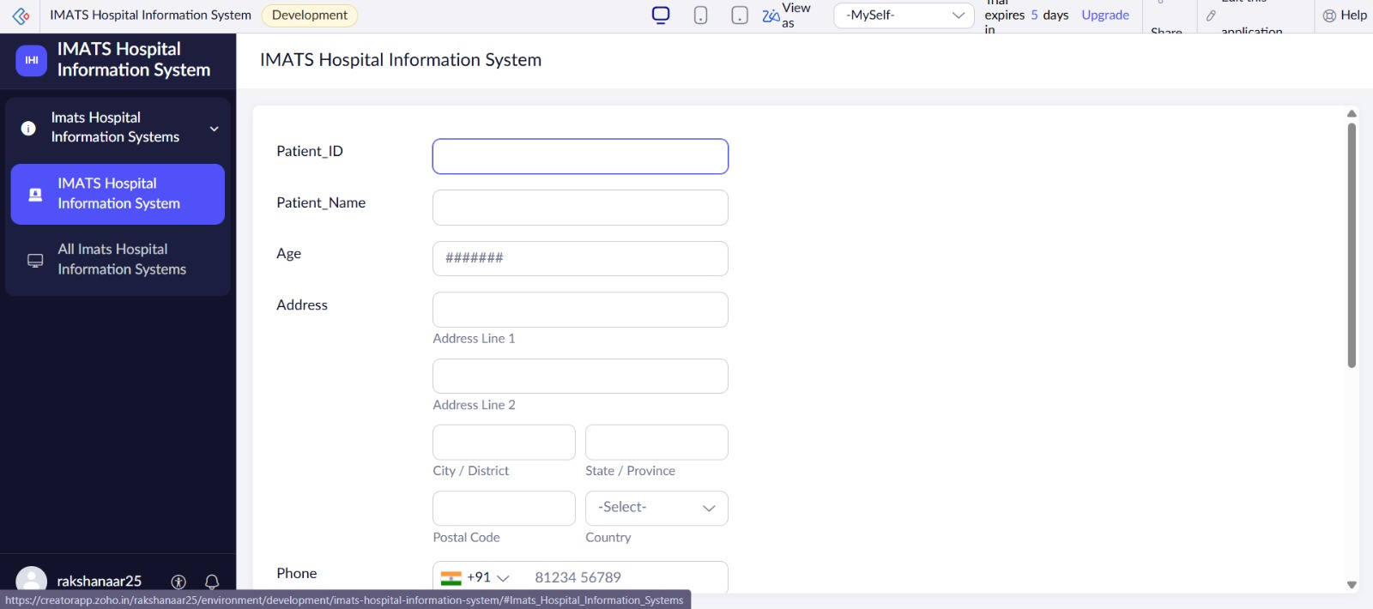
QUESTION 1
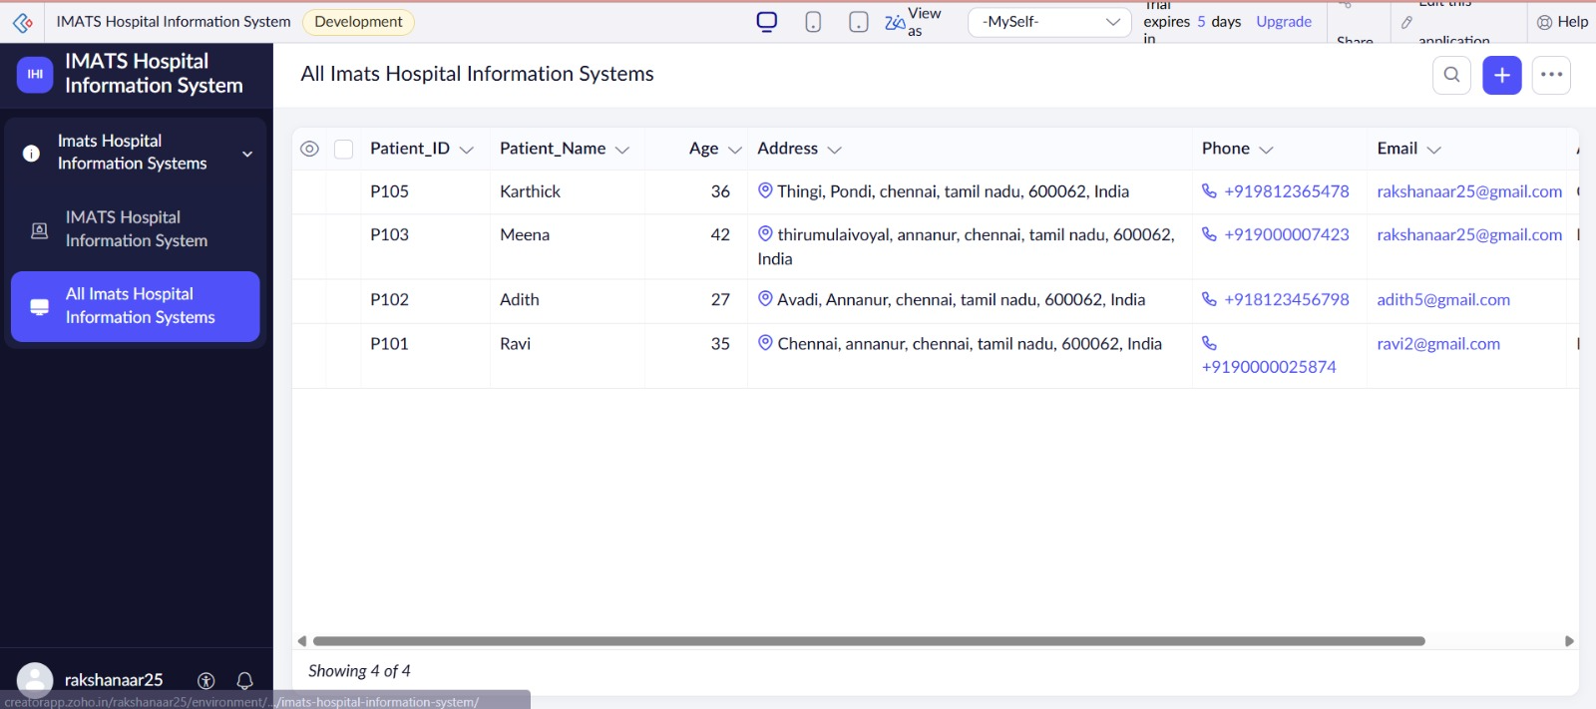

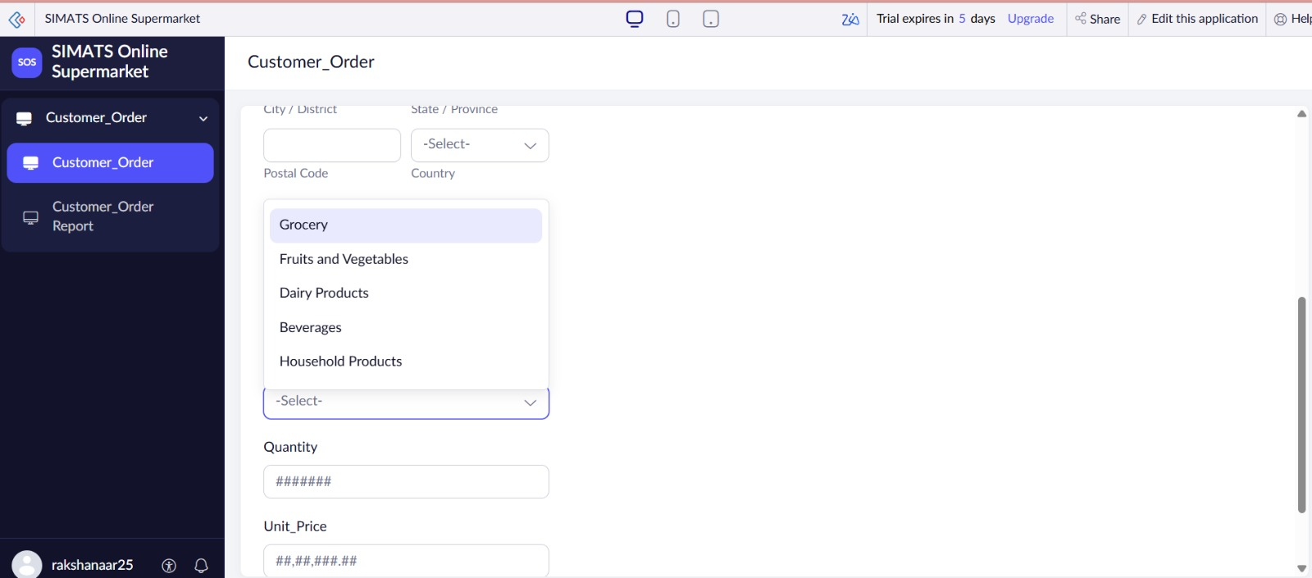
QUESTION 2
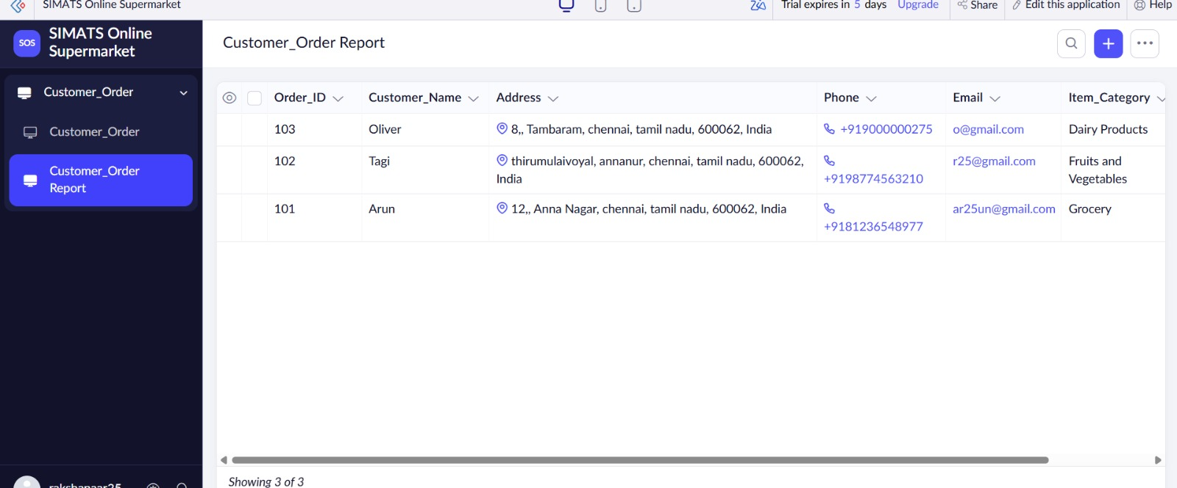
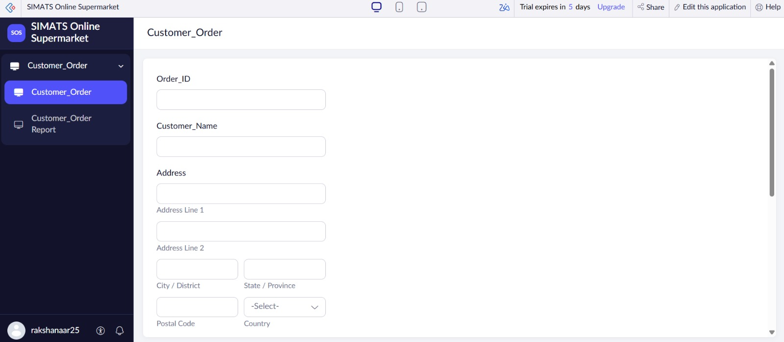
QUESTION 3
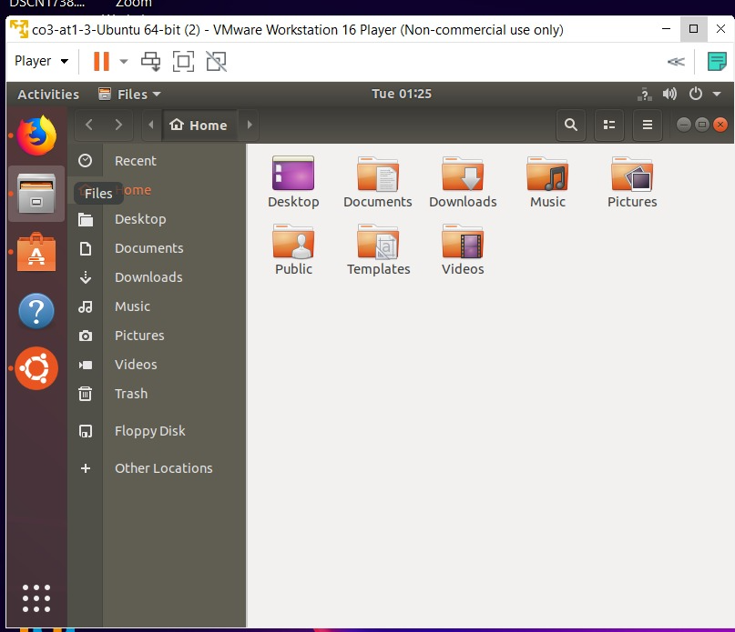

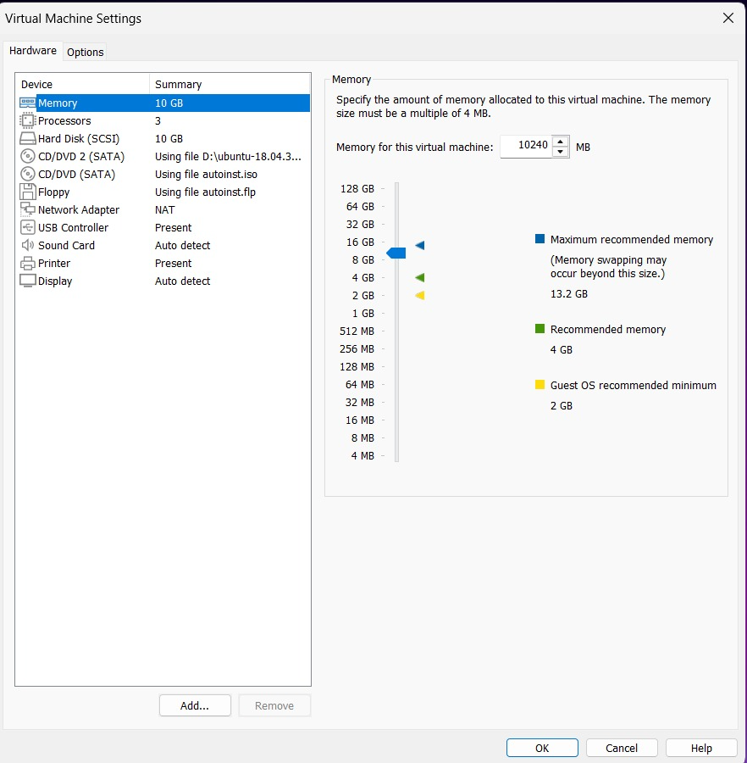
QUESTION 4

